# **Name: Abdurrahman Qureshi**

# **Roll No: 210451**

Practical No: 23

**1)Write a program for student registration using GUI**

**CODE:**

Public Class Form1

Private Sub Button1_Click(sender As Object, e As EventArgs) Handles Button1.Click

Try If TextBox1.Text = "" Or TextBox2.Text = "" Or TextBox3.Text = "" Or TextBox4.Text = "" Then

Throw New RequiredFieldException("All Fields Are Required")Else

MsgBox("Student Registered") End If

Catch ex As Exception

MsgBox(ex.Message)

End Try End Sub

Private Sub Form1_Load(sender As Object, e As EventArgs) Handles MyBase.Load

End Sub

End Class

Public Class RequiredFieldException

Inherits Exception

Public Sub New(ByVal message As String)

MyBase.New(message)

End Sub

End Class

**OUTPUT:**

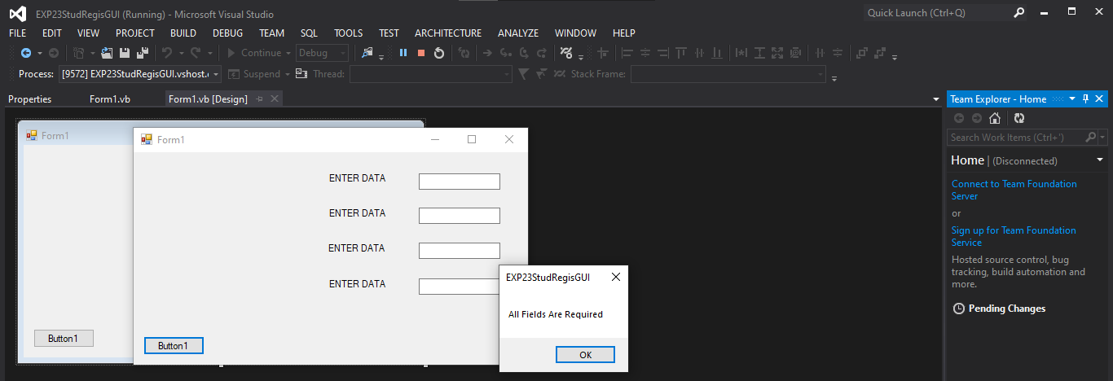

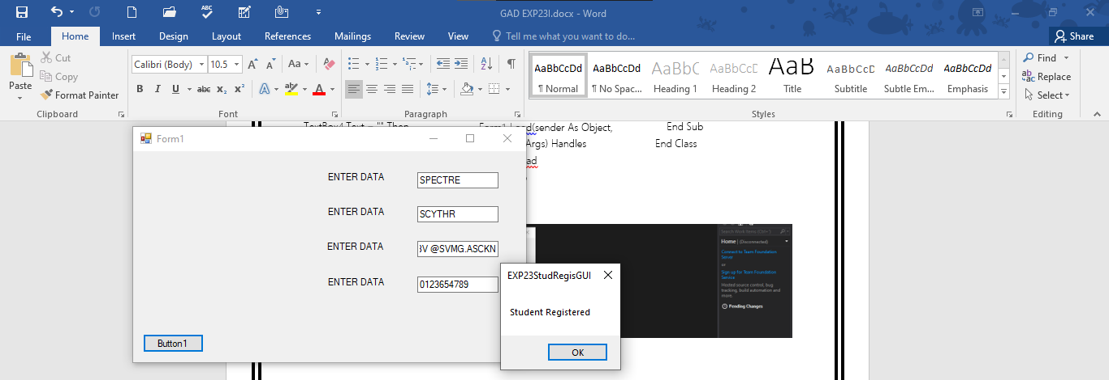

**2)** **Write a program for student registration using exception handling (CLI)**

**CODE:**

Imports System

Module Module1

Sub Main(args As String())

Try

Console.WriteLine("Please Enter Student Details:")

Console.Write("Name: ")

Dim SName As String = Console.ReadLine()

Console.Write("RollNo: ")

Dim rollNo As String = Console.ReadLine()

Console.Write("Phone No: ")

Dim phoneNo As String = Console.ReadLine()

Console.Write("Email ID: ")

Dim emailID As String = Console.ReadLine()

If SName = "" Or rollNo = "" Or phoneNo = "" Or emailID = "" Then

Throw New RequiredFieldException("Please fill in all required fields.")

ElseIf Not IsNumeric(phoneNo) Or Not IsNumeric(rollNo) Then

Throw New NumericFieldException("RollNo & PhoneNo must be Numeric")

End If

Console.WriteLine("Student record saved successfully.")

Catch ex As Exception

Console.WriteLine("Error : " & ex.Message)

Finally

Console.ReadLine()End Try

End Sub

End Module

Public Class RequiredFieldException

Inherits Exception

Public Sub New(ByVal message As String)

MyBase.New(message)

End Sub

End Class

Public Class NumericFieldException

Inherits Exception

Public Sub New(ByVal message As String)

MyBase.New(message)

End Sub End Class

**OUTPUT:** 